CoEvolution – Siemens – Pilot 1 Use Cases
Date: 29.01.2025

In industrial automation, AI components are increasingly important and used to automate for example the management of processes, machine control, or logistics as well as the predictive maintenance of deployed hardware. Often these AI components are brought into the manufacturing environment as part of apps that are executable in an edge computing infrastructure. These apps can be downloaded from marketplaces of edge ecosystems. An app can thereby be provided to the marketplace by third-party vendors. The AI component of the app may have been even developed by another subcontracted party that is supporting the third-party vendor.
Hence, for the end-customer, the operator of the manufacturing plant, it is crucial that security mechanisms are in place to be able to trust the app and its contained AI component. Especially, when apps are part of essential workflow chains (consisting of multiple apps), it is of utmost importance to ensure their security and expected behaviour.

Description of the existing infrastructure and use cases
In this project, we focus on connected AI components that can be used to manage the logistics of the manufacturing environment as well as the management of the network and edge infrastructure itself.

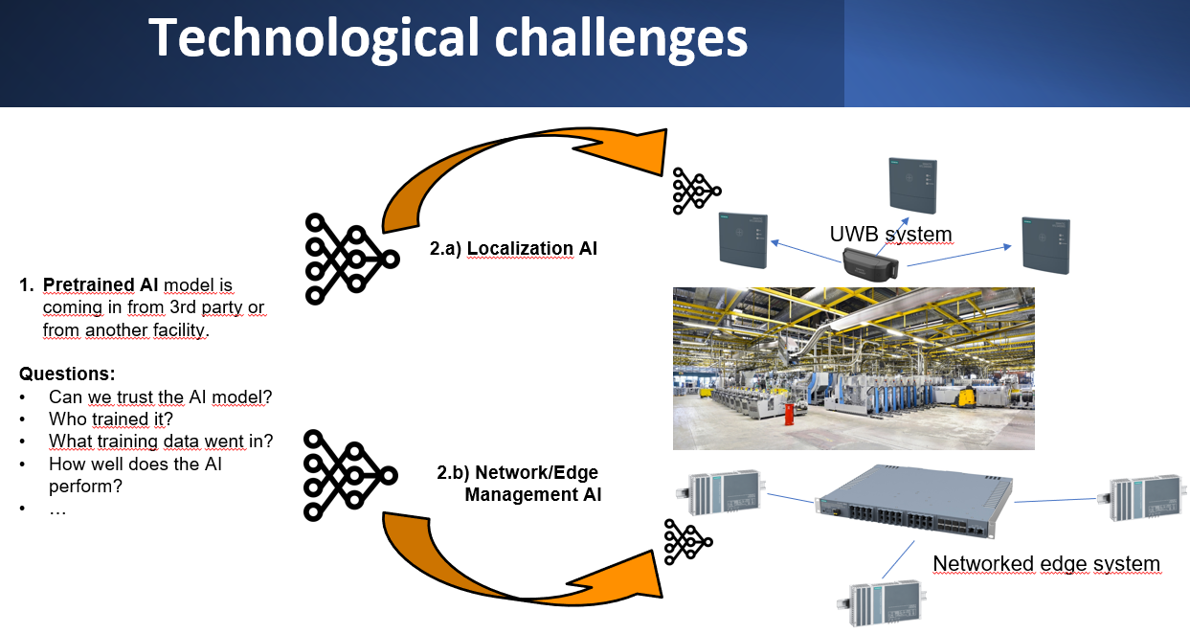
Figure 1: Technological Challenge
As illustrated in the figure above, we assume an AI model comes in (e.g., as part of an edge app) from a third-party vendor or other facility. This is either a pretrained AI that still requires a transfer learning step to be adjusted for the new environment, or it can be used as it is.
Below, two use cases are described. In both cases, it is crucial to be able to trust the AI component. Adversarial attacks that could harm the localization accuracy or the efficiency of the edge resource management, could have substantial negative effects on the productivity of the manufacturing plant.

Use Case 1 - AI-based localization in industrial environment

Description:
In this use case, we consider an industrial plant that is equipped with a real-time indoor localization system (RTLS) that is based on some radio technology (e.g., 5G or Ultrawide Band, UWB). This RTLS needs to provide a localization accuracy between 30 cm and 500 cm depending on the usage scenario. These scenarios range from intralogistics to tool assignment in the process automation (see tables below).
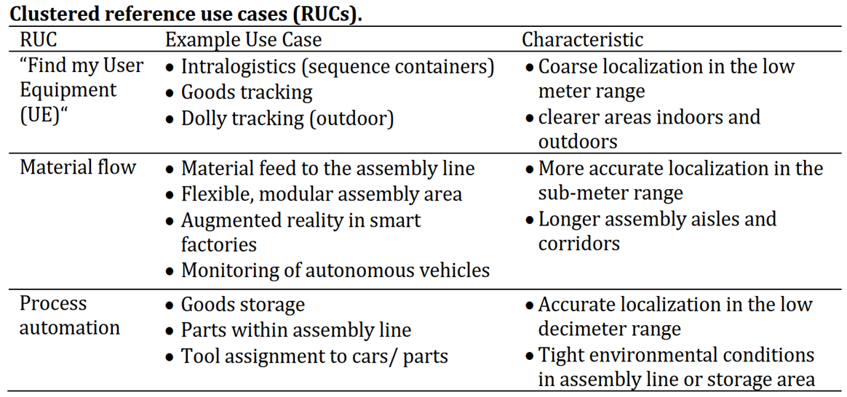

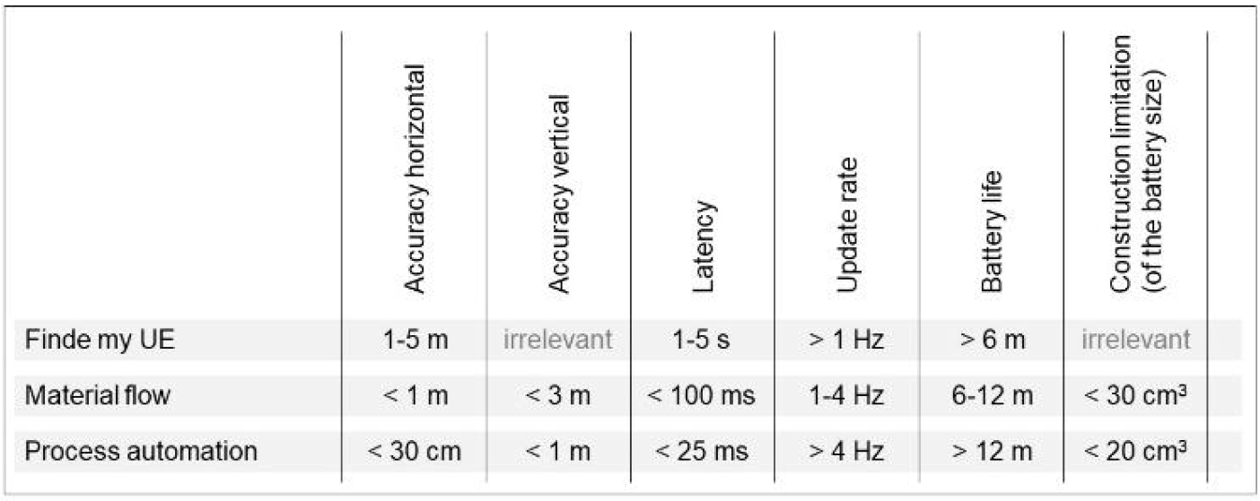

The RTLS uses so-called gateways (in case of 5G these are “radio units” and in case of UWB these are “anchors”), which are deployed in the industrial plant environment at an elevated position and are mapped out at reference locations. These gateways are networked and transmit received signals to a backend service, the localization engine. Then, trackers (UWB uses “tags”, and 5G utilizes User Equipment “UE”) are attached to assets of interest. These trackers send out the radio signals that are received by the gateways. As the gateways are time-synched, and the received signals are time-stamped, the localization engine is able to calculate the position of a tracker using methods such as time difference of arrival (TDoA). Another method of calculating a position is called fingerprinting. Hereby, a previously collected dataset of reference locations and according radio signals is being used to train a neural network in a supervised learning matter.
In order to improve the positioning accuracy, AI models can be used to mitigate errors that occur due to signal attenuation or reflections in the environment. As input to the AI models, the Channel Impulse Response (CIR) is often used, as it implicitly contains information about the characteristics of the environment.
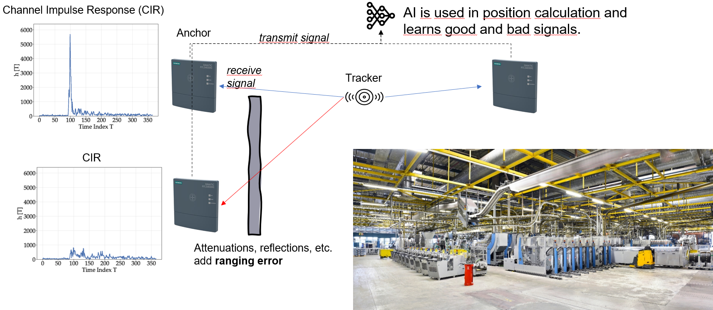
Figure 2: Use Case 1 - AI-based localization in industrial environment
The Figure 3 shows as an example the track of an UWB tag with positions (violet dots) derived from the UWB localization engine with integrated AI-based error mitigation and in parallel the associated reference positions (blue dots), derived through a highly accurate visual localization system. The length of the line between these two points illustrates the error in the position.

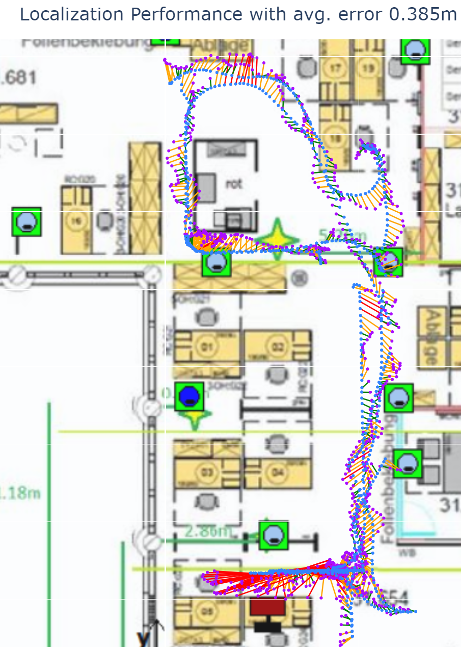
Figure 3: Track of an UWB tag in an office environment determined with TDoA plus AI-based error mitigation (violet dots) in comparison to the reference points (blue dots).
The Figure 4 shows the positions (red dots) determined with AI-based fingerprinting using 5G signals and the according reference positions (blue dots).
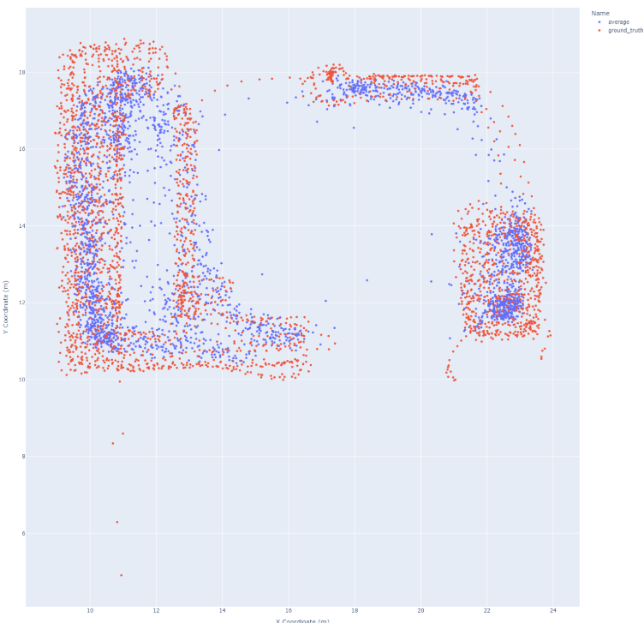
Figure 4: Using 5G signals and fingerprinting-based localization in an industrial environment, this figure shows determined positions (red) and the associated reference positions (blue) as ground truth / labels. The accuracy is 0.713 m.

Business Goals:
Support the Siemens product lines “SIMATIC RTLS” in becoming more reliable and secure by providing methods for highly secure AI usage within the localization process. Hence, this use case aims to incorporate the advanced security measures

Components:
To implement the use case, the following components are involved:
- Localization AI: This AI model supports the logistics of the manufacturing environment, and it can for example be utilized to improve the localization accuracy of tracked assets.
- Localization beacon devices: These devices enable wireless localization of tracked assets.
- Localization tag devices: These devices are being localized by the beacons and carried by the tracked assets.

Available Data:
Datasets for training AI models to support this use case will be already publicly available or made available. Candidate datasets are:
- IPIN 2023 – Track 7: 5G CIR in warehouse: https://evaal.aaloa.org/2023/data (most likely candidate)
- IPIN 2022 - Track 7: CIR in warehouse can be used to train AI model: https://evaal.aaloa.org/2022/data

- TDoA dataset @ IIOT Lab from Ghent University

Demo Setup:
In case of this use case 1, a deployed and running lab environment to collect location data will be not possible in the framework of CoEvolution. Instead, it is required to use simulated or existing data and feed those into our localization pipeline to calculate positions. Based on those data sets, the localization can be replayed under different circumstances (e.g., under security threats).

User Stories

User Story 1.1: Deploy, Setup & Train the RTLS
As a system integrator (an engineer at a contracted third-party engineering firm), I want to deploy, setup and train the RTLS using reference locations and collected signal data so that it can accurately calculate positions and adapt to the unique characteristics of the environment.

Detailed Description of “Deploy, Setup & Train the RTLS”:

Actors:
- System Integrator: Third-party company personnel that conducts the deployment, setup and training to configure and calibrate the RTLS for optimal accuracy.
- Warehouse Manager: Customer of the system integrator who plans to use the RTLS for asset training.
- RTLS System Vendor: Company that produces and sells the hardware components (gateways and trackers) as well as the software components (localization engine) to determine asset positions.
- RTLS System: Includes trackers, gateways, and the localization engine.
- Assets: Raw materials, finished goods, tools, and equipment.
- Training Dataset: Signal data collected at known reference locations for model training.
- AI/ML Model: Used to enhance the accuracy of the position calculation process.

Preconditions:
- The warehouse manager has purchased the RTLS system (hardware components and software) from the RTLS System Vendor.

Main Flow:
- Localization Engine Installation: System integrator installs the software of the RTLS system (including an untrained AI model) in the backend / data center of the customer / warehouse.
- Gateways Deployment: System integrator positions gateways (radio units or anchors) at predetermined reference points throughout the plant and map their exact coordinates in the system.
- RTLS Setup: System integrator installs gateways with localization engine, realizes time-synchronization, and maps to their exact reference positions.
- System Calibration: Initial configuration of tracker signal parameters (e.g., frequency, power level).
- Defined Training Plan: System integrator defines a structured plan for collecting signal data at various reference locations across the plant.
- Tracker Deployment: System integrator places trackers (tags or UEs) at known reference locations within the environment.
- Signal Data Collection: System integrator triggers the collection signal data emitted by trackers at the reference locations and capture parameters such as: Time Difference of Arrival (TDoA), Signal strength and quality, Channel Impulse Response (CIR).
- Dataset Creation: Create a dataset that correlates the known reference locations with the captured signal data.
- AI Model Training: Use the collected dataset to train an unsupervised machine learning model. The model learns patterns in signal behavior within the plant and characteristics of signal attenuation, reflection, and noise caused by the environment.
- Federated Learning for good quality signal selection:
  - Implement Deep Embedded Clustering (DEC) for Time Difference of Arrival (TDoA) at each anchor. Each anchor trains a local model on its collected data to generate latent-space embeddings and clusters signals into a pre-defined number of clusters (k). Poor-quality signals are filtered out based on quality criteria, and only Time of Arrival (TOA) data from high-quality signals is sent to the backend for tag or UE positioning.
  - During each training round, local DEC models from all anchors are aggregated at a central server to update a global model. The updated global model is then redistributed to anchors, enabling continuous improvement of local training in subsequent rounds. This process ensures robust anchor selection and enhances signal clustering for accurate positioning.
- Validation: Using moving trackers at additional known locations not used during training to validate the model’s accuracy. Compare the system’s calculated positions with the actual locations.
- Calibration and Fine-Tuning: Adjust the model based on validation results to address discrepancies. Iterate the training process as needed, especially when the environment changes (e.g., new machinery is added or layouts are modified).

Requirements:
- Environmental Adaptation: The trained model compensates for environmental changes.
- Error Reduction: The system minimizes errors in challenging areas with signal interference.
- Sufficient Training Data: As a functioning deployment of a lab setup requires too many efforts, use existing training datasets to run experiments.

User Story: 1.2 Asset Tracking
As a warehouse manager, I want to track the real-time location of raw materials, work pieces, finished goods or tools and equipment. My goals are to use the locations to do e.g., inventory management (reduce search time for assets), loss prevention (prevent theft or unauthorized removal of equipment), or predictive analytics (predict equipment usage patterns and schedule proactive maintenance).

Detailed Description of “Asset Tracking”

Actors:
- Warehouse Manager: Oversees inventory and coordinates material movements.
- RTLS System: Includes trackers, gateways, and the localization engine.
- Assets: Raw materials, finished goods, tools, and equipment.
- Staff: Workers interacting with tracked assets.

Preconditions:
- RTLS System Setup:
  - Gateways are deployed and mapped to reference locations.
  - Trackers are attached to assets.
  - The localization engine is reachable by the gateways via the network and the localization engine receives the signals from the trackers at the backend and is combined with an AI that corrects positions calculated with TDoA.
  - Determined positions can be displayed / mapped.
- System Training:
  - RTLS is trained to determine accurate positions based on received radio signals from trackers.
- Defined Asset Information:
  - Each tracker is associated with a unique asset ID in the system.

Main Flow:
- Tracker Activation: Each tracker attached to an asset begins transmitting signals.
- Signal Reception: Gateways detect tracker signals, digitalize them and forward data (e.g., timestamp, CIR) to the localization engine.
- Data Reception: Localization engine receives the data (digitalized signal) to calculate a position.
- Position Calculation: The localization engine computes the real-time position of the asset using methods like Time Difference of Arrival (TDoA).
- Position Refinement: AI-based error mitigation ensures accurate positioning, accounting for environmental factors like reflections and obstructions.
- Data Visualization: Positions of tracked assets are displayed on a map of the facility.

Requirements:
- System Accuracy: The RTLS achieves the required positional mean average error (MAE) for position calculations (e.g., 95% is ±50 cm or better).

Use Case 2 - AI-based edge / network management

Description:
In this use case, we consider an industrial production cell that consists of networked edge devices and software components, called edge apps, that run on these devices. Together, the edge apps realize a certain process automation functionality. For the purpose of this use case, we consider the example of an automated processing of work pieces that run over a conveyor belt and are being sorted according to quality using visual inspection. Several apps are involved to realize this. AI-based tooling is used to efficiently manage the edge infrastructure, i.e. to optimally allocate apps on edge devices and to solve problems in the edge infrastructure (Figure 5). Now, it is crucial that these AI-based components are running securely and are trustworthy.

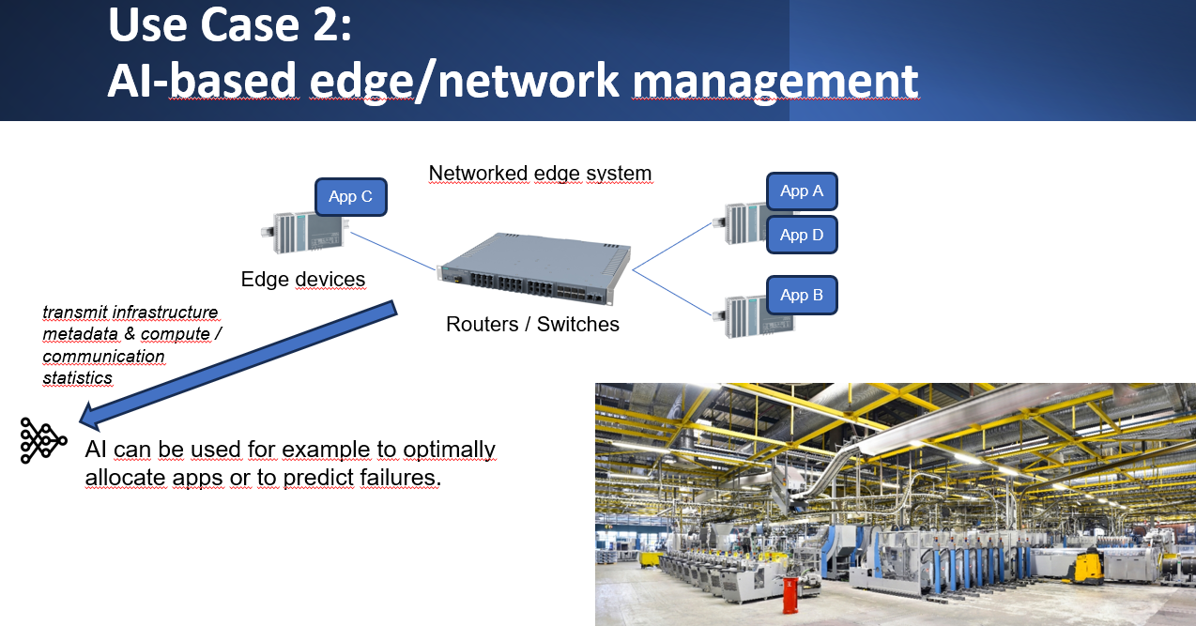
Figure 5: Use Case 2 - AI-based edge / network management

Business Goals:
Support the Siemens product lines “Industrial Edge” and “SCALANCE” in becoming more reliable, observable and secure by providing methods for highly secure AI usage within an industrial edge/network infrastructure. In order to leverage previous work, this use case builds on the pilot currently being developed in the PANDORA EU HORIZON projects and extends this pilot through the advanced security measures developed within CoEvolution.

Workflow:
A conveyor belt is used to transport work pieces. A light barrier triggers a camera, and an arm sorter is triggered to sort out “bad” work pieces. Therefore, the camera images are classified by an edge app that contains an AI to classify the images in “good” or “bad” work pieces. An edge app that realizes a virtual programmable logic controller (vPLC) implements this control logic. With the purpose of cost saving and improved maintenance, a vPLC (instead of a PLC) is utilized for the logic control, which can run as an edge app. The light barrier, and arm sorter are connected via a Siemens ET200 device and the camera is connected with ethernet to the AI app.
The involved edge apps and devices are managed by the Siemens’ Industrial Edge (IE) product. Each edge device runs an app execution environment. The edge apps, sensors (e.g., cameras), actuators, and vPLC can communicate via industrial networks. The IE Manager (IEM) offers an API to do lifecycle management of the devices and apps. An Orchestration Agent and its UI ChatBot allow an easy-to-use administration of the edge management in natural language. The scope of CoEvolution’s work on this use case is limited to the aspects of infrastructure management rather than the application logic.

Components:
To implement the use case, the following components are involved:
- Edge devices: these are devices that can host edge apps. Such an edge app may incorporate an AI model. For example, as a kind of edge device, the Siemens IPC 1047E (link) can be utilized, combined with a Siemens ET200 device to establish connectivity to sensors and actuators.
- Edge apps:
  - Siemens SIMATIC S7 vPLC (link) is used to realize the process flow.
  - Siemens AI inference server app (link) is a candidate to realize the visual classification.
  - Network/Edge Orchestrator/Management: This is a dedicated edge app that contains an AI model to support the management of the network / edge infrastructure, and it can for example be utilized to efficiently manage edge resources and installed apps.
- Network switch devices: These devices allow the creation of connected edge networks.
- Experiment setup components: conveyor belt, light barrier, network camera, arm sorter

The Siemens product “Industrial Edge” is being utilized to manage the software components, the edge apps, running on those edge devices. The networking between the devices is established through switches / routers of the Siemens SCALANCE product portfolio. The process logic controllers (PLC) of the SIMATIC product line can be used to realize the functionality of the process automation.

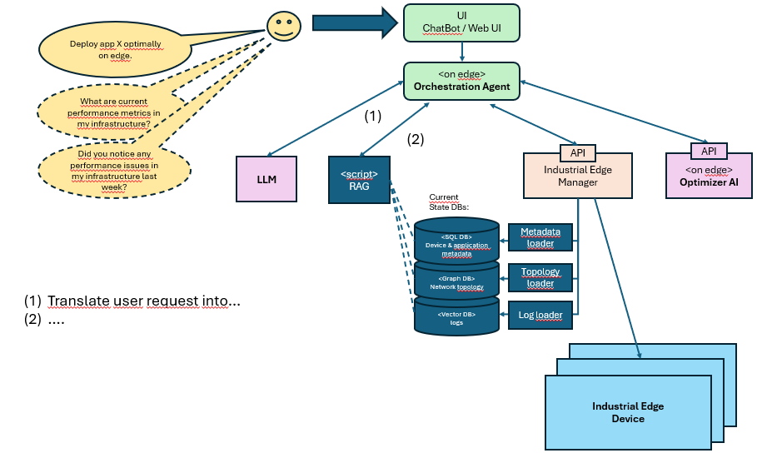
Figure 6, System architecture UC 1.2

Available Data:
Datasets for training AI models to support this use case will be made available. For example:

- Server machine data, such as compute metrics (e.g., user CPU load average over 1, 5, 15 minutes) and network metrics (e.g. bytes sent/received, packets dropped)
- Edge metrics, such average loading time, service interruptions, app partitions, propagation delays
- Textual data from system logs

Demo Setup:
In case of this use case 2, a lab environment will be deployed and based on the efforts of the EU HORIZON project “PANDORA”. Re-using already funded demonstration setup will allow the most effective utilization of EU funding. Before a physical setup will be deployed, a simulated environment will be used to create relevant training data.

User Stories

User Story 2.1: Integrate Orchestration Agent and use for efficient Edge Management
As a Plant Manager (personnel employed by the manufacturing plant’s company), I want to have a UI ChatBot that enables an easy management of my infrastructure (edge + network). The ChatBot should identify relevant and remarkable system conditions and events of the edge infrastructure. It should be capable to give insights interactively. Furthermore, it should identify persisting system problems and propose counter measures.

Actors
- System Integrator: Third-party company personnel that conducts the integration.
- System Administrator: responsible for managing the edge and network infrastructure.
- Plant Manager: Customer of the system integrator who wants to use the orchestration agent for their manufacturing plant.
- Infrastructure System Vendor: Company that produces and sells the hardware components (edge & network devices) as well as the software components to manage plant infrastructure.
- Data sources: historical and real-time resource usage, network topology and performance metrics, application metadata, logs.
- Infrastructure components: edge devices, network.
Preconditions:
- Physical edge devices and network components are installed and connected to the infrastructure.
- Management tooling is available and installed on the relevant systems (e.g., industrial edge manager).
- LLM is installed and accessible

Main Flow
- System integrator identifies “current state” databases, for application and device metadata, network topology, logs, etc.
- System integrator installs agent and setup LLM
- System integrator links agent to “current state” databases
- System integrator validates setup by running test chats (user queries) on UI Chatbot.
- System administrator utilizes UI ChatBot to interact with the Orchestration Agent:
  - System administrator asks ChatBot to deploy a new app and therefore triggers the Optimizer AI.
  - System administrator asks ChatBot for system condition
  - System administrator asks ChatBot for possible fault resolution

Postconditions:
- After system administrator asks ChatBot to re-configure the system, the system is infact configured according to the request.

User Story 2.2: Efficient Infrastructure Management
As a System Administrator, I want to efficiently manage the edge infrastructure. I.e., I want to optimally allocate apps to edge devices based on their resource availability and operational demands, taking into account the available network and compute resources.

Actors:
- System Administrator: responsible for managing the edge and network infrastructure.

- Infrastructure System Vendor: Company that produces and sells the hardware components (edge & network devices) as well as the software components manage plant infrastructure.
- Management tooling: e.g., some edge orchestrator and infrastructure manager.
- AI model: integrated in the management tooling.
- Infrastructure components: edge devices (hosting edge apps) and network.
Preconditions:
- Physical edge devices and network components are installed and connected to the infrastructure.
- Management tooling is available and installed on the relevant systems (e.g., industrial edge manager).
- Operational policies or requirements for app allocation and efficiency (e.g., app priority levels, acceptable latency) are defined.
- Edge app programs are ready to be installed.

Main Flow:

- System administrator logs in to the management tooling interface using secure credentials.
- System administrator configures the edge & network infrastructure:
  - Register and configure available edge devices and their details.
    - Assigning unique identifiers to each device.
    - Configuring device metadata (e.g., location, hardware capabilities).
  - Sets up communication links between devices and the management system.
- System administrator installs management tooling including already trained AI
- System administrator defines resource and operational parameters:
  - Inputs resource availability parameters for each device (e.g., CPU, memory, network bandwidth).
  - Defines operational constraints, e.g.:
    - Priority levels for critical apps.
    - Latency thresholds for real-time apps.

- System administrator activates management tooling to activates orchestration for edge apps.

Postconditions:
- Management tooling is fully operational, orchestrating edge app allocation based on defined policies.
- Resource utilization across edge devices is optimized, and app performance meets operational requirements.
- The system is capable of dynamically adapting to changing demands and workloads.

Requirements:

- Scalability: The management tooling must handle a growing number of edge devices and apps without significant performance degradation.

